**Summary of Excel Dashboard**

**Overview of Credit Card Transaction Excel Dashboard**

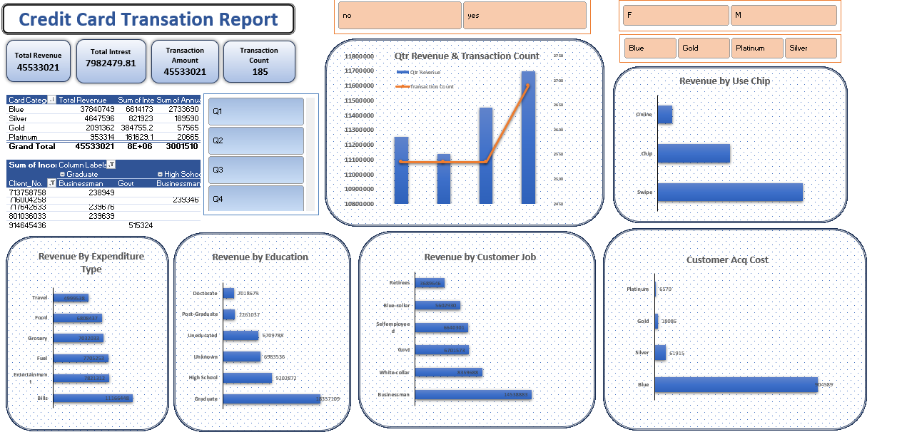

This **Credit Card Transaction Report** dashboard provides insights into revenue, interest, transaction counts, customer segmentation, and spending patterns. Key components include:

1. **KPIs (Top Metrics)**
   * **Total Revenue**: 45,533,021
   * **Total Interest**: 7,982,479.81
   * **Transaction Count**: 185
2. **Category-wise Analysis**
   * Breakdown by **Card Type (Blue, Gold, Platinum, Silver)**
   * Revenue and transaction count trends by **Quarter (Q1–Q4)**
   * Revenue segmentation by **Expenditure Type, Education, and Job**
3. **Usage Behavior**
   * **Revenue by Chip Usage** (Online, Chip, Swipe)
   * **Customer Acquisition Cost (CAC)** by Card Type

**Steps to Create Pivot Tables for Dashboard**

1. **Insert Pivot Table**
   * Select the **dataset** with transactions.
   * Go to **Insert → PivotTable** and place it in a **new sheet**.
2. **Create Required Pivot Tables**
   * **Revenue by Card Type**
     + **Rows**: Card Category
     + **Values**: Sum of Revenue
   * **Revenue by Customer Job**
     + **Rows**: Customer Job
     + **Values**: Sum of Revenue
   * **Revenue by Education**
     + **Rows**: Education Level
     + **Values**: Sum of Revenue
   * **Transaction Count by Quarter**
     + **Rows**: Order Date (Grouped by Quarters)
     + **Values**: Count of Transactions
   * **Usage Type Analysis**
     + **Rows**: Payment Method (Chip, Swipe, Online)
     + **Values**: Sum of Revenue
   * **Customer Acquisition Cost (CAC)**
     + **Rows**: Card Type
     + **Values**: Sum of Acquisition Cost
3. **Create Visualizations**
   * Convert Pivot Tables into **Bar, Line, and Column Charts**.
   * Apply **Slicers** for filtering by **Gender, Card Type, and Yes/No Options**.